System Security: Estimates

| August-20 |

**Document Overview**

**Documentation Goals**

This documentation is intended to provide instruction for ***Security within the Estimation Programs****.*

**Table of Contents**

**Estimate Buttons on Tabs** 2

Program Master [NS8] 2

Browse Programs 2

View Programs 3

User Groups 3

**Estimating Farm Tab Program Master Security** 4

Program Master [NS8] 4

Browse Programs 4

View Programs 4

**Estimating Farm Tab Security by Menu** 5

Security Access by Menu [NS6] 5

Choose Menus 5

Update Security 5

# **Estimate Buttons on Tabs**

## Program Master [NS8]

### Browse Programs

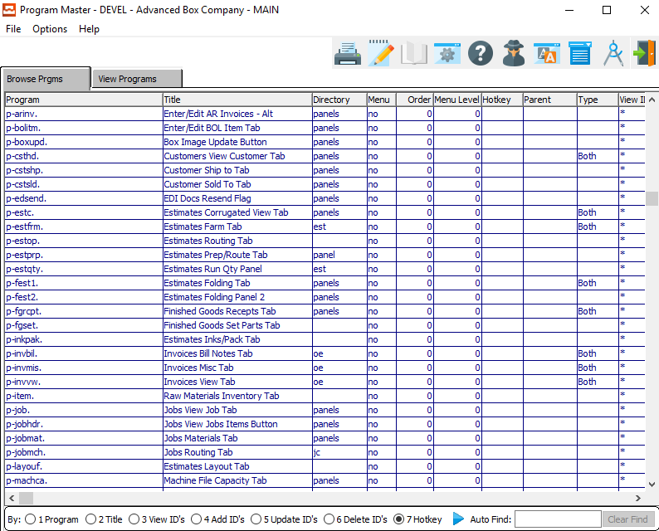

The programs that start with (p- ) are the buttons on the *Estimate* tabs.

The user can search for their desired program by using the *Auto Find* search box at the bottom of the screen. To find all estimate programs, switch the *Search By* toggle to (*2 Title*), and type *Est*.

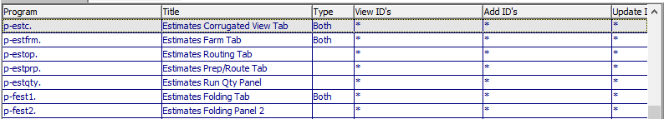

One the system administrator has highlighted their desired program within the list, they may set security by either *User Group* or *User ID* view the *View Programs* tab.

Please Note: *User Groups* are best.

### View Programs

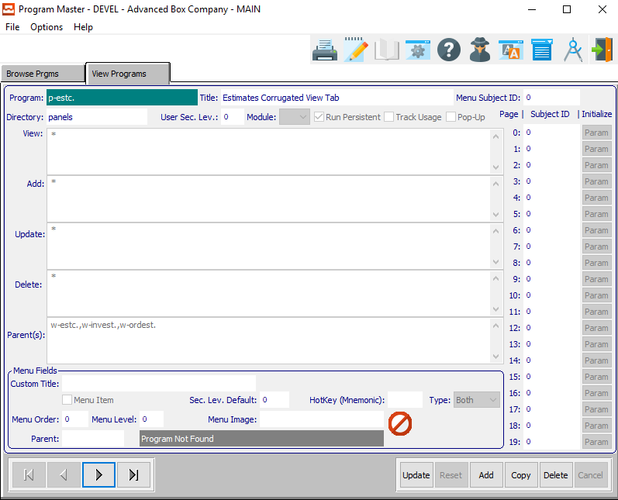

An asterisk (*) within any of these fields means that everyone can access that portion of the program.

#### View ID’s

The *View ID’s* is to set up who can view the data within the currently selected program.

#### Add ID’s

The *Add ID’s* is security for who can add data within the currently selected program.

#### Update ID’s

The *Update ID’s* is security for who can update existing data within the currently selected program.

#### Delete ID’s

The *Delete ID’s* is security for who can delete existing data within the currently selected program.

### User Groups

Under ***“N”-“U”-“5”***, the user can add groups, and assign users to that group. Then, if a user is hired or fired, the system administrator may simply change the users within the group that the employee belongs to. Therefore, no security will need to be changed.

If a user does not have access, the selected button will be grayed out.

# **Estimating Farm Tab Program Master Security**

## Program Master [NS8]

### Browse Programs

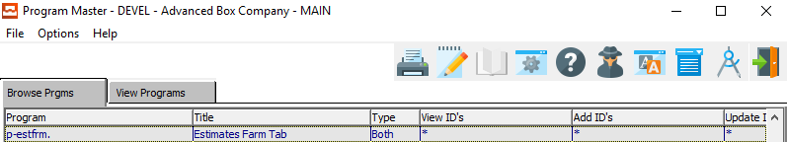

The programs that start with (p- ) are the buttons on the *Estimate* tabs.

Security for the *Estimates Farm Tab* can be found within the (p-estfrm.) program.

### View Programs

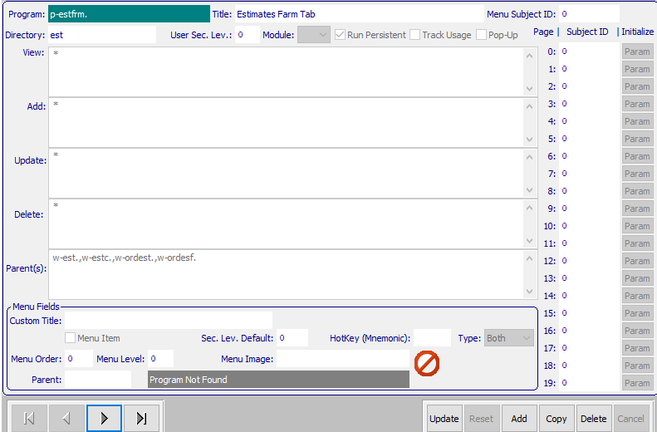

An asterisk (*) within any of these fields means that everyone can access that portion of the program.

#### View ID’s

The *View ID’s* is to set up who can view the data within the *Estimates Farm Tab* program.

#### Add ID’s

The *Add ID’s* is security for who can add data within the *Estimates Farm Tab* program.

#### Update ID’s

The *Update ID’s* is security for who can update existing data within the *Estimates Farm Tab* program.

#### Delete ID’s

The *Delete ID’s* is security for who can delete existing data within the *Estimates Farm Tab* program.

# **Estimating Farm Tab Security by Menu**

## Security Access by Menu [NS6]

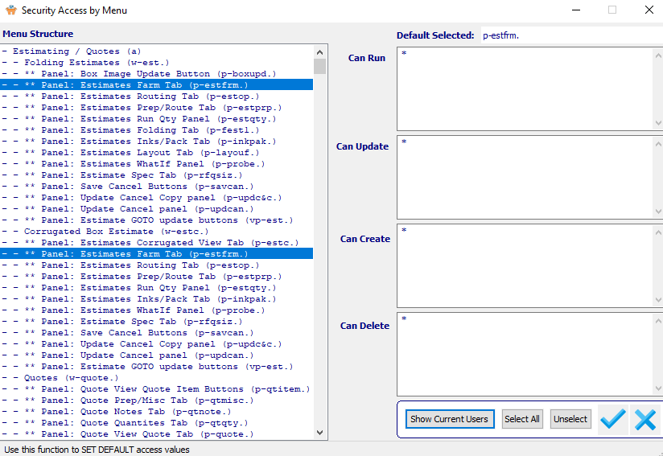

### Choose Menus

Security for the *Estimates Farm Tab* can be found within the (p-estfrm.) program.

The user may choose their desired *Estimate Farm Tab* by clicking on it to highlight it within the list of available Estimate Menus. To choose multiple menu options, the user can use the ***“Control-Click”*** method.

Highlighted programs can all have their security updated at once in order to save time.

### Update Security

An asterisk (*) within any of these fields means that everyone can access that portion of the program.

#### Can Run

The *Can Run* section is to set up who can view the data within the *Estimates Farm Tab* program.

#### Can Update

The *Can Update* section is security for who can update existing data within the *Estimates Farm Tab*.

#### Can Create

The *Can Create* section is security for who can add data within the *Estimates Farm Tab* program.

#### Can Delete

The *Can Delete* section is security for who can delete existing data within the *Estimates Farm Tab*.